**Robot NICO – installation manual**

Ed.1  
Date: 04.03.2021  
Place: FT Lab, DAI FMFI UK Bratislava

## Prerequisities

Own notebook with Windows 11 installed. Connection to internet and USB connection to robot NICO.

## Health and Work safety

Usual precautions for work with electrical device apply. Please note that robot is not strong enough to cause serious injury to person, nevertheless it can damage itself when hitting obstacle, desk or itself.

Take care! Prior switching the robot off, hold robot arms if elevated. Loss of torque in motors would cause that robot arms would fall and could be damaged. After switching robot off put robot arms slowly on the desk.

After usage, please cover the robot with anti-dust sheet.

## Installation process overview

Please take into account that the whole process of installation may take several hours.

The process consists of the following steps

1. Installation of necessary software packages
2. Installation of software packages specific for robot NICO
3. Checking of communication ports
4. Checking of basic robot functionalities

## Installation of necessary software packages

Installation files for robot NICO are stored on GitHub. To download them in batch, install git application from webpage:

<https://git-scm.com/download/win>

Download and run installation file for windows with recommended settings. After installation, you can check version of git installed with command

  git --version

It is strongly recommended to create a specific virtual environment due to the need for specific python packages. Please note that original software packages for robot NICO were created in 2017, therefore for compatibility reasons there is a need for specific version of several software packages. There can be compatibility issues with newer python packages.

For creation of Conda virtual environment first download miniconda for Windows from

<https://docs.conda.io/projects/conda/en/stable/user-guide/install/windows.html>

Select miniconda installer for Windows

Install miniconda with recommended settings

Open windows command line interface (press Win + R then run 'cmd' command or start 'powershell')

Change directory to your working directory according to your preferences, e.g.

cd c:\NICO

Run

  conda create --name nico python=3.12

This will create virtual environment with name 'nico' (you can select name your wish) with python for windows version 3.12.

Activate this environment by typing

conda activate nico

You should see (nico) before prompt

Further installation commands will be performed inside this virtual environment and will not affect previously installed python version and its packages (if any).

You can deactivate conda environment by typing command

conda deactivate

You can check installed version of python in virtual environment by command

python -V

and versions of installed python packages by command

pip list

Download requirements.txt file from https://github.com/branozigo/NICO-robot---tutorial

Run

 pip install -r requirements.txt

Installation can take more than 30 minutes.

Robot NICO uses in arms and neck Dynamixel servomotors and in hand it uses servomotors with controller that partially simulates controller functionality on Dynamixel servomotors. Install Dynamixel Wizard which will enable you to manipulate with Dynamixel servomotors directly on the low level.

From the page

<https://emanual.robotis.com/docs/en/software/dynamixel/dynamixel_wizard2/>

select software download for Windows and install the program.

Then perform the scan of all ports (it can take few minutes). Only native Dynamixel servomotors will be visible, and you will be able to manipulate with them manually.

Fig. 1 Setting scanning parameters

Fig. 2 Scanning in progress

Fig. 3 Scanning results

## Installation of software packages specific for robot NICO

Copy NICO software from github

git clone <https://github.com/knowledgetechnologyuhh/NICO-software.git>

Directory NICO-software shall be created

Go to its subdirectory ..../NICO-software/api/src/nicomotion

In the file setup.py

remove or mark with # following lines:

extra = {}  
if sys.version_info >= (3,):  
    extra["use_2to3"] = True

and also the line   **extra

and modify line

 packages=find_packages("scripts/"), to  packages=find_packages("scripts"),  [remove /]

Then in this directory run command:

python setup.py install

## Checking of communication ports

Robot NICO communicates with your notebook via USB interface on which are two virtual COM ports created by windows OS. Exact numbers are assigned by Windows operating system and may differ from computer to computer. Therefore, it is necessary to check them and adapt software accordingly prior starting communication with the robot.

One port is assigned for face mimic controlled by Arduino board behind robot face. The second port controls servomotors. You can find COM port numbers by using Dynamixel Wizard or by running the script

python COM_port_test.py

The script is stored on github <https://github.com/branozigo/NICO-robot---tutorial>

The script should provide two COM port numbers.

## Checking of basic robot functionalities

COM port with lower number should be used for mimic control. From github download the script NICO_Mimic_Control_2.py and update COM port number on the line

class NicoMimicController:  
 def __init__(self, port='COM4', baudrate=9600)

to the lower from the values provided by port checking script. Then run

python NICO_Mimic_Control_2.py

You should see LED lights at NICO face representing emotions - something like this:

Fig. 4 NICO face emotions

To check NICO’s cameras, run script

python camera_upd2.py

You should see horizontally concatenated pictures from both NICO „eyes“. Video is recorded automatically. You can perform snapshot by pressing „s“. You should see something like this:

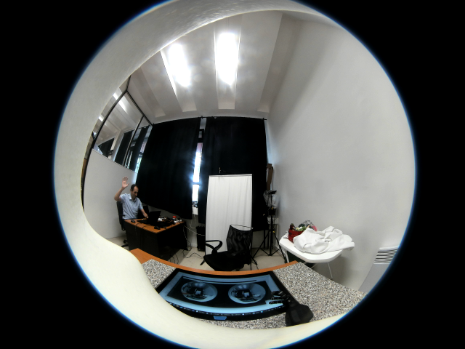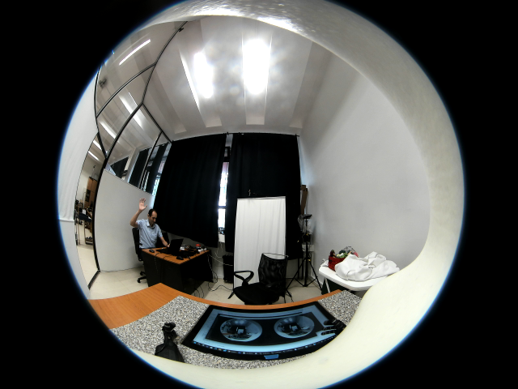

Fig. 5 View through NICO cameras

To check and move servomotor in NICO’s neck use the script

python Dynamixel_Pypot_Test.py

Script should display all Dynamixel servomotors IDs and move NICO’s head.